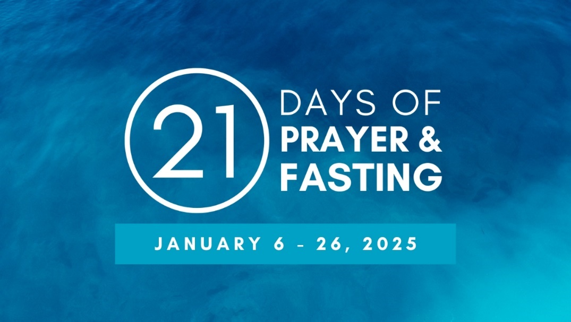

NIGHTLY SERVICES IN PERSON or ONLINE

Hosted by different churches every night. For the most up to date information,   
go to [esali.org](http://www.esali.org/) or [NorthparkChurch.org/fasting](http://www.NorthparkChurch.org/fasting)

MONDAY – FRIDAY 7:00 – 8:00 p.m.  
SATURDAY & SUNDAY 6:00 – 7:00 p.m.

**MONDAY, JANUARY 6 – First Armenian Presbyterian**430 S 1st St, Fresno, CA 93702   
www.youtube.com/FAPCFresno

**TUESDAY, JANUARY 7 – Westside Church of God**1422 W. California Ave., Fresno, CA 93706  
[www.wscog.org](http://www.wscog.org)

**WEDNESDAY, JANUARY 8 – New Covenant Church**1744 E Nees Ave, Fresno, CA 93720  
[www.youtube.com/@newcovfresno/streams](http://www.youtube.com/@newcovfresno/streams)

**THURSDAY, JANUARY 9 – Clovis Christian Church**1701 Locan Ave., Clovis, CA 93619  
[www.cloviscc.com/live-stream](http://www.cloviscc.com/live-stream)

**FRIDAY, JANUARY 10 – Crosspoint Church**2518 N Cedar Ave, Fresno, CA 93703   
[www.youtube.com/CrosspointFresno](http://www.youtube.com/CrosspointFresno)

**SATURDAY, JANUARY 11 – Northwest Church**5415 N West Ave., Fresno CA 93711   
[www.nwc.org](http://www.nwc.org)

**SUNDAY, JANUARY 12 – Mountain View Church**3600 N. Fowler Ave., Fresno, CA 93727  
[www.mountainview.org](http://www.mountainview.org)

**MONDAY, JANUARY 13 – House of the Gospel**3941 E Mono Ave., Fresno, CA 93702  
www.youtube.com/@houseofthegospel/featured

**TUESDAY, JANUARY 14 – City Church**2025 East Dakota, Fresno, CA 93726  
[www.youtube.com/citychurchfresno](http://www.youtube.com/citychurchfresno)

**WEDNESDAY, JANUARY 15 – B****ethany Church**9161 N Maple Ave, Fresno, CA 93720  
[www.youtube.com/bethanychurchfresno](http://www.youtube.com/bethanychurchfresno)

**THURSDAY, JANUARY 16 – Saints Community COGIC**3740 E Ashlan Ave, Fresno, CA 93726   
[www.saintscommunity.org/watch-live](http://www.saintscommunity.org/watch-live)

**FRIDAY, JANUARY 17 – First Presbyterian Church**1540 M St, Fresno, CA 93721  
[www.youtube.com/firstpresfresno](http://www.youtube.com/firstpresfresno)

**SATURDAY, JANUARY 18 – Family Christian Assembly**535 N Cedar Ave, Fresno, CA 93702  
[www.youtube.com/user/ChristianTemple559](http://www.youtube.com/user/ChristianTemple559)

**SUNDAY, JANUARY 19 – Valley Christian Center**4649 E Shields Ave, Fresno, CA 93726   
[www.youtube.com/c/ValleyChristianCenterFresno](http://www.youtube.com/c/ValleyChristianCenterFresno)

**MONDAY, JANUARY 20 – Breaking Free Revival Center**3510 N Millbrook Ave, Fresno, CA 93726  
[www.youtube.com/@breakingfreerevivalcenter5577](http://www.youtube.com/@breakingfreerevivalcenter5577)

**TUESDAY, JANUARY 21 – University Vineyard**4910 N Woodrow, Fresno, CA 93726  
[www.universityvineyard.com](http://www.universityvineyard.com)/livestream

**WEDNESDAY, JANUARY 22 – Saint Rest Baptist Church**1550 E Rev Chester Riggins Ave., Fresno CA 93706  
[www.youtubecom/@saintrestbaptistchurch7799](http://www.youtubecom/@saintrestbaptistchurch7799)

**THURSDAY, JANUARY 23 –** **Cross City Christian Church**2777 E Nees Ave, Fresno, CA 93720  
<https://live.mycrosscity.com>

**FRIDAY, JANUARY 24 – The Word** with Northpark  
2611 E Hammond Ave, Fresno, CA 93703   
​<https://www.youtube.com/@thewordfresno5420/streams>

**SATURDAY, JANUARY 25 – Clovis Hills Church**795 E. International, Clovis, CA 93619  
[www.clovishills.online.church](http://www.clovishills.online.church)

**SUNDAY, JANUARY 26 **CELEBRATION** Cornerstone Church**1545 Fulton St, Fresno, CA 93721  
[www.youtube.com/@cornerstonefresno/streams](http://www.youtube.com/@cornerstonefresno/streams)

*updated 12/12/24*